Ocean acidification impacts growth and calcification in Pacific oyster (Crassostrea gigas) larvae

Evidence in Pacific oysters (Crassostrea gigas) for a short term compensatory mechanism to deal with decreased calcium carbonate availability in acidified conditions.

Limited resilience in oyster larvae exposed to elevated pCO2 conditions

---
Emma Timmins-Schiffman, Michael O’Donnell, Carolyn Friedman, and Steven Roberts

ABSTRACT
Increasing atmospheric carbon dioxide equilibrates with surface seawater and dissolves to create greater concentrations of hydrogen ions. This process, ocean acidification, is a future and contemporary concern. Atmospheric pCO₂ is expected to increase in the foreseeable future, further contributing to ocean acidification. Upwelled waters along the coast frequently exhibit high pCO₂ and low pH levels. In this study, Pacific oyster (Crassostrea gigas) larvae were exposed to three different pCO₂ conditions: Ambient (400 µatm), MidCO₂ (700 µatm), and HighCO₂ (1000 µatm). After 24 hours of exposure to HighCO₂ conditions calcification was increased in larvae compared to other treatments. Larvae raised until 3 days post-fertilization under HighCO₂ conditions were smaller and less calcified than those in lower pCO₂. Elevated pCO₂ did not influence developmental rate. These findings are consistent with other reports of negative impacts of elevated pCO₂ in shellfish and indicate that oyster larvae possess compensatory mechanisms to combat ocean acidification.

INTRODUCTION
Ocean acidification is expected to affect ecosystems at an accelerating pace over the next century (IPCC 2007; Caldeira and Wickett 2003). Ocean acidification occurs due to the reduction of seawater pH in association with the uptake of anthropogenic CO₂ and resultant increased H⁺ ion concentration. Many of the projected changes will have significant consequences for natural populations ranging from physiological changes to broad-scale range shifts (Talmage and Gobler 2011; O’Donnell et al. 2009; Wong et al. 2011; Tomanek et al. 2011; Banks et al. 2010; Perry et al. 2005).
Pacific oyster (Crassostrea gigas) larvae can be exposed to acidified waters throughout their planktonic period. The highest concentrations of pCO₂ are in the near-surface waters of the ocean (Sabine et al. 2004), where larvae in the plankton tend to congregate. Similarly, oceanic upwellings along the west coast of North America can expose larvae to water that is low in pH (sometimes as low as pH 7.6) and undersaturated with respect to aragonite (Feely et al. 2008). Aragonite is an important component of many larval shells and when seawater is undersaturated, this form of calcium carbonate is less available to organisms.
The dissolution of CO₂ in seawater also results in elevated concentrations of bicarbonate (HCO₃⁻) and decreased levels of carbonate ion (CO₃²⁻). The latter effect impacts calcifying organisms since they rely on the availability of CO₃²⁻ to form and maintain carbonate-based structures (Beniash et al. 2010; Thomsen and Melzner 2010). Many adult aquatic invertebrates can dissolve their calcified structures to make HCO₃⁻ more available as a buffer against internal acidosis. This phenomenon has been observed in oysters Crassostrea gigas (Lannig et al. 2010), limpets Patella vulgata (Marchant et al. 2010), and urchins Psammechinus miliaris (Miles et al. 2007). It is not clear to what degree larvae can utilize this mechanism to maintain homeostasis under elevated CO₂ conditions.
Sustained environmental change, such as ocean acidification, can negatively affect both the ecosystem and economy. Oysters provide important ecosystem services such as improved water quality and benthic-pelagic coupling through the filtration of large volumes of water, release of feces to the benthos, and creation of habitat via reef formation (Coen and Luckenbach 2000). In addition to their ecological roles, molluscs are economically important to many coastal communities worldwide. In 2008, molluscs comprised 64.1% (or 13.1 million tons) of total aquaculture production, with oysters accounting for 31.8% of the total production (FAO 2010). Recently, in the Pacific Northwest of the U.S., concern has heightened over the already apparent effects of corrosive, acidified water on both natural and hatchery production of C. gigas larvae (Elston et al. 2008, Feely et al. 2010).
This study characterized the effects of two elevated levels of pCO₂ on size, calcification and development during early larval stages of the Pacific oyster, Crassostrea gigas. Oyster larvae were raised in two elevated levels of pCO₂ (700 and 1000 µatm) and ambient (400 µatm) seawater for 72 hours following fertilization. While the 1000 µatm exposure did have a significant impact on larvae, there is evidence that oyster larvae can effectively deal with transient exposure to elevated pCO₂ .

METHODS
Seawater chemistry manipulation
Experimental conditions were maintained using a flow-through seawater system in Friday Harbor, Washington, USA. Water entering the system was filtered (0.2 µm), UV sterilized, and CO₂-depleted using membrane contactors (Membrana, Charlotte, NC, USA) under partial vacuum. Three experimental treatments were chosen to correspond with dissolved CO₂ levels of 400, 700 or 1000 ppm in the atmosphere. These levels correspond to near current ambient oceanic conditions, projections for mid-century pCO_{2,} and end-of-century, respectively (IPCC 2007). These CO₂ levels also reflect those currently observed in near and inshore marine waters of the northeastern Pacific (Feely et al. 2008). These three treatments will be referred to throughout the manuscript as Ambient, MidCO₂, and HighCO₂. Set-point pH levels were determined with the program CO₂SYS (Robbins et al. 2010) using an average alkalinity of 2060 µmol kg⁻¹ based on total alkalinity measurements taken the week prior to the experimental trial.
Larval C. gigas were held 3 L microcosms within a large reservoir filled with the respective treatment water. Ambient air stripped of CO₂ by a CO₂ adsorbtion unit (Twin Tower Engineering, Broomfield, CO, USA) was used to aerate the seawater within the reservoirs. This replaced oxygen lost through the degassing process. Reservoir pH was continuously monitored by a Durafet III pH probe (Honeywell, Morristown, NJ, USA) and pure CO₂ (Praxair, Danbury, CT, USA) was added to each system by a Honeywell UDA2182 pH controller in order to maintain pH in the three systems.
Seawater was pumped from the reservoir into larval microcosms through irrigation drippers (DIG Industries, Sun Valley, CA, USA) at a rate of 1.9 L per hour. An outflow tube at the top of the microcosms fitted with 35 µm mesh allowed water to exit the microcosms while retaining larvae. All systems were equilibrated to the correct treatment level 48 hours prior to the start of the experiment. Water temperature was held at 20.4°C ± 0.4°C

Oysters
Ten female and four male adult C. gigas were collected from Argyle Creek in Friday Harbor, WA in July 2011. Oysters were strip-spawned with eggs and sperm pooled separately (day zero). Pooled eggs (approximately 2 million) were divided equally into 18 7.5cm diameter containers. Sperm was diluted in Ambient seawater and added to each container of eggs. After the addition of sperm, the eggs were gently agitated and incubated for 15 minutes to allow for fertilization.
Six containers of fertilized eggs were transferred to microcosms containing one of three treatment conditions. Initial densities post-hatching were approximately 1 larva mL⁻¹. On days 1 and 3 post-fertilization, larvae were randomly sampled to determine survival, size, developmental stage, and degree of calcification. For each microcosm sampled, larvae were filtered onto 35 µm mesh screens and washed. Approximately 100 larvae were removed from each tube. Larvae were relaxed with 7.5% MgCl₂ and fixed in 4% paraformaldehyde buffered in filtered seawater. The remaining larvae were returned to cleaned microcosms filled with new seawater. Larvae were fed Dunaliellia sp. and Isochrysis sp. at concentrations of 30,000 cells mL⁻¹ each on day two. During feeding, water flow was turned off in microcosms for two hours. All microcosms were cleaned at each sampling event.
Larvae were examined using light microscopy to determine size, developmental stage and degree of calcification. Larval hinge length and shell height were measured at 10x magnification with a Nikon Eclipse E600 and NIS Elements Basic Research software (Nikon, Tokyo, Japan). Larval developmental stage and calcification were determined at 20x magnification using an inverted microscope and double polarized light for calcification. Larvae were scored as calcified on day 1 post-fertilization if calcification was observed at the hinge. On day 3 post-fertilization, larvae were classified as fully calcified if polarized light produced a “Maltese cross” in the larval shell (Figure 1; LaBarbera 1974).

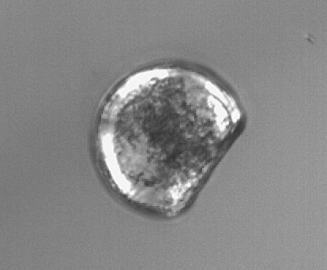
Figure 1. Fully calcified D-hinge C. gigas larva revealing a Maltese cross under polarized light.

Carbonate chemistry
Throughout the experiment salinity was measured with a conductivity meter (Hach sensION5; Loveland, CO, USA) and temperature was measured using a Fluke 1523 thermometer (Fluke, Everett, WA, USA). Seawater pH entering the microcosms was measured daily using the spectrophotometric (spec) technique outlined in SOP 6b by Dickson et al. (2007) to confirm pH measurements from the Durafet probe. When any discrepancies were observed, the Durafet probe was recalibrated. Seawater pH measurements were taken from two microcosms per treatment on days 0, 1, and 3. Final pH values reported here have been corrected for dye addition and temperature. Total alkalinity (A_{T}) was measured following the open cell titration of SOP 3b (Dickson et al. 2007). Samples for A_{T} were taken from incoming water and from two microcosms in each treatment on days 0, 2, and 3. CO₂SYS (Robbins et al. 2010) was used to calculate calcium carbonate saturation state (Ω) of aragonite and calcite, carbonate ion concentrion, and pCO₂ with A_{T} and pH as inputs using the following constants: Lueker et al. (2000) for CO₂ Constants, Dickson (1990b) for KHSO₄, Total scale (mol kg⁻¹ SW) for pH scale, and Wanninkhof (1992) for Air-Sea Flux.

Statistics
Differences in larval size among treatment were examined using a two-way ANOVA with fixed effects of treatment and day followed by Tukey’s Honestly Significant Difference test (Tukey’s HSD). A one-way ANOVA was also used to test for differences in larval size among treatments using the combined fixed factor of day-treatment. Larval calcification and developmental stage were compared among treatments using a generalized linear model (GLM). Binomial error distributions were used for GLM analyses. All analyses were performed in R (R Development Core Team 2011).

RESULTS
Carbonate chemistry
Throughout the experiment seawater pH differed across treatments and A_{T} varied with natural fluctuations in the local water (Table 1). Mean seawater pH was consistent within but varied among treatments (Figure 2). Mean pH, as measured by the Durafet pH probes (Figure 2) was 7.99 in the Ambient treatment, 7.75 in the MidCO₂ treatment and 7.66 in the HighCO₂ treatment. Aragonite and calcite saturation states were greater than 1.0 for the duration of the experiment, except in the HighCO₂ treatment on days 1 and 2 (Table 1). Carbonate ion concentration was lowest in the HighCO₂ treatment (average ± SD of 61.15 ± 4.05 µmol kg⁻¹ seawater, Table 1), intermediate in MidCO₂ (74.05 ± 6.43 µmol kg⁻¹), and highest in the Ambient treatment (120.24 ± 11.52 µmol kg⁻¹). Partial pressure of CO₂ in the seawater averaged 468 µatm in the Ambient treatment, 847 µatm in the MidCO₂ treatment, and 1065 µatm in the HighCO₂ treatment.

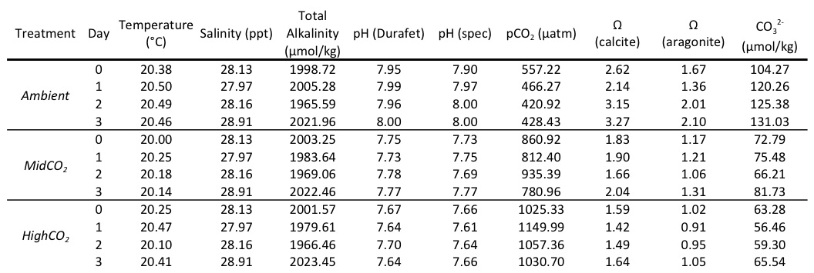 Table 1. Water chemistry data for three experimental treatments – Ambient, MidCO₂, and HighCO₂. Temperature and Durafet pH measurements are averages from each day based on the Honeywell controller logs. Salinity, total alkalinity (A_{T}), and spectrophotometric (spec) pH are point measurements taken each day. Partial pressure of CO₂, Ω, and CO₃²⁻ were calculated from spec pH and A_{T}.
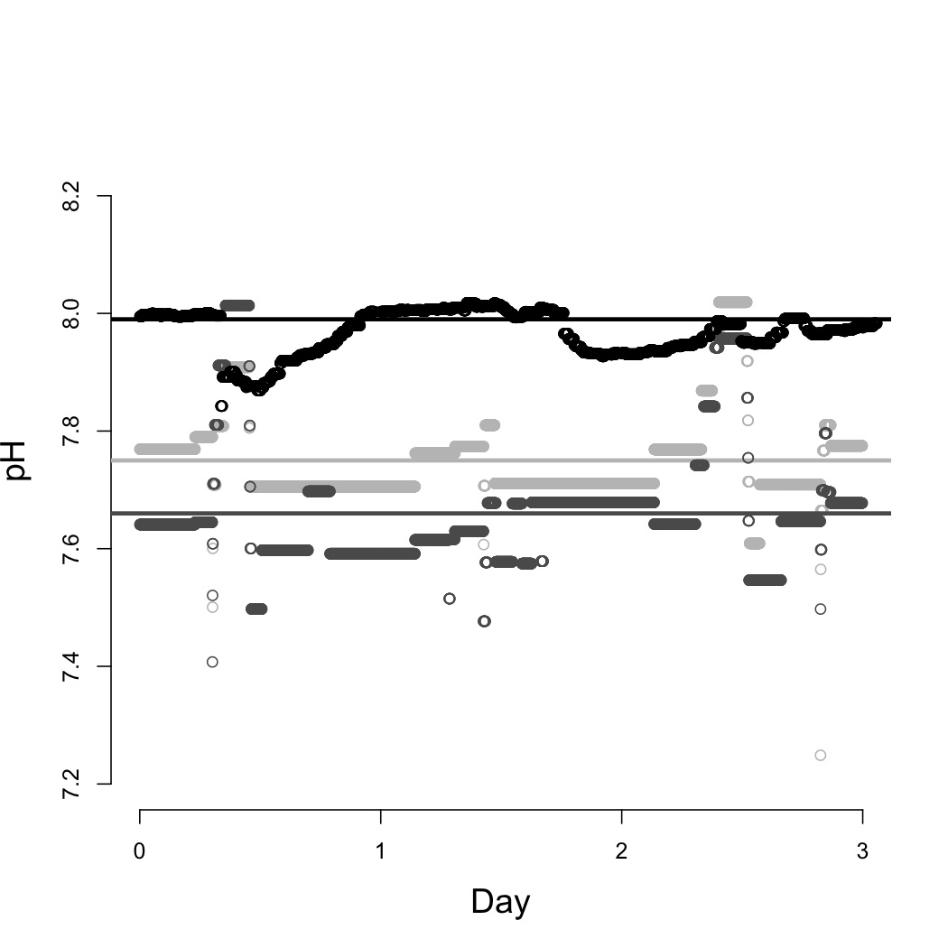
Figure 2. Profiles of pH measurements in the three different treatments – Ambient (black), MidCO₂ (light gray), and HighCO₂ (dark gray). Average pH for the experiment for each treatment is represented by solid lines. The Durafet probes recorded pH measurements every minute.

Size, development, and calcification
Larval size (shell height and hinge length) was similar across experimental treatments after 24 hours, however by day 3 larvae grew significantly larger (height and length) in the Ambient and MidCO₂ compared to the HighCO₂ treatment (Table 2, Figures 3 and 4). Between days 1 and 3 larvae increased in size under Ambient conditions (shell height, p < 1e-7) and MidCO₂ conditions (shell height and hinge length, p < 1e-7 and p = 7.4e-6, respectively; Figures 3 and 4).
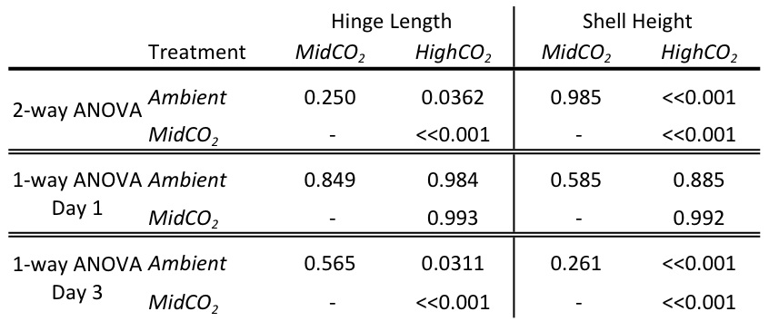
Table 3. Results from post-hoc Tukey’s HSD following ANOVA for comparisons of hinge length and shell height among treatments. The 2-way ANOVA was performed with “treatment” and “day” as fixed effects and the one-way ANOVA was performed with the fixed effect of “day-treatment”.

Developmental rate did not vary across treatments. On day 1, a slightly greater proportion (0.977) of larvae at HighCO₂ were at the D-hinge stage (compared to those that were still trocophores), but this difference was not significant (z-value=1.016, p=0.310; data not shown). The proportion of larvae at the D-hinge stage in the Ambient treatment was 0.875 and in MidCO₂ was 0.833. By day 3, all larvae observed across treatments were at the D-hinge stage.
Larval calcification was significantly different between treatments for days 1 and 3 post-fertilization. Following 24 hours of treatment (day 1) calcification was greatest in the HighCO₂ treatment (z-value=2.084, p=0.0372, Figure 5). On day 3, larvae at HighCO₂ conditions were less calcified than the other two treatments (z-value=-3.203, p=0.00136).
Survival was near 100% in all the treatments on day 1. On day 3, survival was remained near 100% in the Ambient treatment, and was approximately 85% in both the MidCO₂ and HighCO₂ treatments.

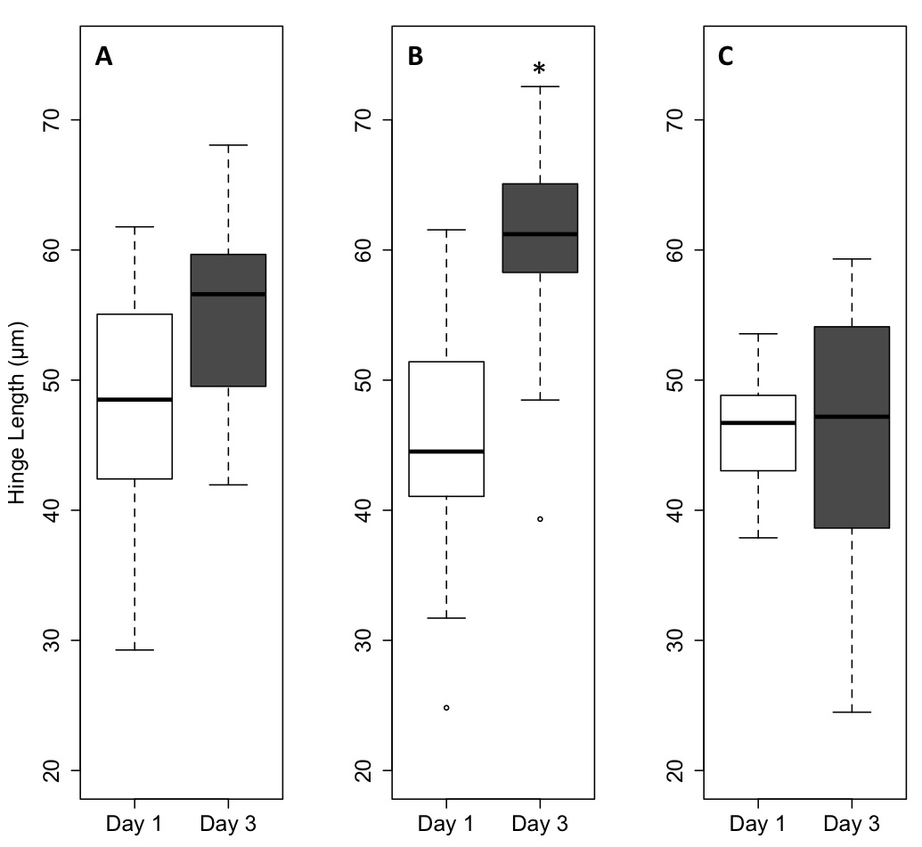
Figure 3. Larval hinge length by on day 1 (white boxplots) and day 3 (gray boxblots). Results are shown for the Ambient treatment (panel A), MidCO₂ treatment (panel B), and HighCO₂ treatment (panel C). Boxplots contain the middle 50% of the data and the bars extending from the plots encompass the data within 1.5x the spread of the middle 50%. Open circles represent outliers. Horizontal black bars indicate median values. On day 3, larvae in the HighCO₂ treatment are significantly smaller than those in the other two treatments (p < 0.05). Only the larvae raised in the MidCO₂ treatment were significantly larger on day 3 compared to day 1 (p < 0.01).
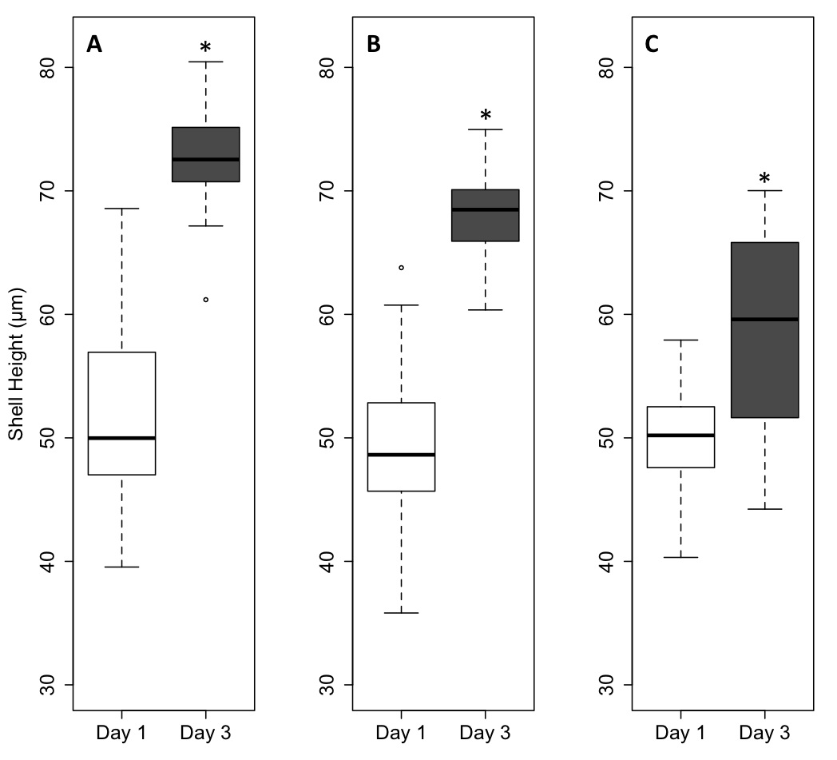

Figure 4. Larval shell height on day 1 (white boxplots) and day 3 (gray boxblots). Results are shown for the Ambient treatment (panel A), MidCO₂ treatment (panel B), and HighCO₂ treatment (panel C). Boxplots contain the middle 50% of the data and the bars extending from the plots encompass the data within 1.5x the spread of the middle 50%. Open circles represent outliers. Horizontal black bars indicate median values. On day three, larvae at HighCO₂ had shorter shell height than the larvae raised at Ambient and at MidCO₂ (p < 0.01). Shell height in all three treatments increased significantly from day 1 to 3 (p < 0.01).
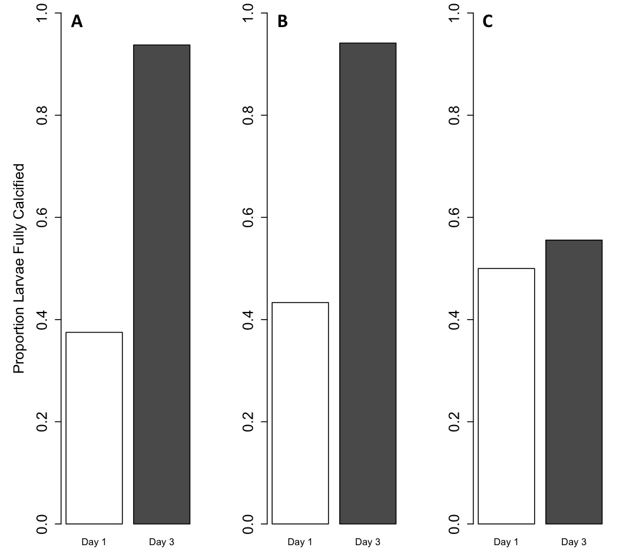
Figure 5. Proportion of larvae calcified exposed to elevated pCO₂. Bars represent calcification on day 1 (white) and day 3 (gray). Proportion larvae calcified are provided from the Ambient treatment (panel A), MidCO₂ treatment (panel B), and HighCO₂ treatment (panel C). There is a significant difference in calcification between treatments, with the highest proportion larvae calcified at HighCO₂ on day 1 and the fewest larvae calcified in HighCO₂ on day 3.

DISCUSSION
In this study we have demonstrated that C. gigas larvae tolerate moderate acidification in early development, however an acute, high pCO₂ exposure (HighCO2, about 1000 µatm) impacts size and calcification following a 72 hour exposure. The chemistry scenarios simulated in this study are based on projections for the coming century, but these values of low pH and Ω are already occurring with increasing frequency in the nearshore waters off the U.S. West coast (Feely et al. 2010; Hauri et al. 2009), which is habitat to C. gigas and other bivalve species. In the Pacific Northwest, hatchery water supply comes from adjacent natural bays and when upwelling events occur, the water that enters the hatchery can reach pCO₂ near 1000 µatm (S. Alin, unpublished data; B. Eudeline, pers. comm.).

Impact of elevated pCO₂ on size and calcification
Larvae raised at HighCO₂ were smaller and less calcified by day 3 post-fertilization, though no delay in developmental progress was observed. These results are consistent with another study of C. gigas larvae in which elevated pCO₂ resulted in decreased growth and shell mineralization (Kurihara et al. 2007). Kurihara et al. (2007) raised larvae to 48 hours post-fertilization at an elevated pCO₂ of about 2268 µatm, much higher than pCO₂ projected for the coming century. In contrast to our study, Kurihara et al. 2007 reported an effect on calcification at 24 hours post-fertilization and showed a developmental delay in reaching the D-hinge stage. It is likely the observed differences are related to higher pCO₂ used by Kurihara et al. 2007.
Other larval bivalves are sensitive to elevated pCO₂, although C. gigas appears to be comparatively robust to these changes. Elevated pCO₂ of 750 ppm (Ω_{Ar} of about 1.0, CO₃²⁻ of about 60 µmol kg⁻¹ seawater) had significant negative effects on hard clam (Mercenaria mercenaria) and bay scallop (Argopecten irradians) larvae as evidenced by decreased survival, development, growth and lipid synthesis (Talmage and Gobler 2011). The comparable exposure conditions in our study (MidCO₂) did not have a negative impact. The differential responses observed across species could be indicative of differential species resistance. Another explanation could be the different experimental manipulations of seawater. For instance, in many of these scenarios, Ω_{Ar} or CO₃²⁻ concentration may be the primary culprit, as opposed to elevated pCO₂. C. gigas larvae exposed to different ocean acidification scenarios after fertilization demonstrated decreased viability, size and calcification only when the concentration of CO₃²⁻ was low, irrespective of pCO₂ level (Gazeau et al. 2011). Gazeau et al. (2011) discovered that pH, pCO₂, and A_{T} are not the significant drivers in the observed negative effects of ocean acidification on C. gigas larvae, but rather are proxy indicators of the effects of decreased CO₃²⁻ concentrations. In our study, the aragonite saturation state (Ω_{Ar}) and CO₃²⁻ concentration were considerably different in the HighCO₂ treatment. Both Gazeau et al. (2011) and Kurihara et al. (2007) reported CO₃²⁻ values around 40 µmol kg⁻¹ seawater with Ω_{Ar} of 1.6 and 0.68, respectively. The CO₃²⁻ in the HighCO₂ treatment was approximately 60 µmol kg⁻¹ seawater and the Ω_{Ar} averaged 0.98 across the four days. As evidenced by these three studies, larval C. gigas size and calcification decrease when the carbonate chemistry is altered in such a way as to make CO₃²⁻ less available. Through nuanced studies, such as Gazeau et al. (2011), species-specific responses to various carbonate chemistry changes induced by ocean acidification can be uncovered.
A smaller size of larvae at higher pCO₂ could lead to several ecological disadvantages. Smaller veliger larvae are not able to feed as efficiently as larger ones (Strathmann and Leise 1979). Larval sand dollars, Dendraster excentricus, responded to increased pCO₂ through changes in morphology that resembled a starvation response without the usual compensation of longer arms that allow for greater food capture (Chan et al. 2011). Exposure to ocean acidification altered the larval sand dollar ciliary beat pattern, thus decreasing the efficiency of particle capture, leading to decreased stomach size (Chan et al. 2011). C. gigas larvae also depend on ciliary movement for feeding, although the direct effects of ocean acidification on this mechanism are unknown. In this study we cannot determine if decreased ability to acquire food or less available energy for growth is the main cause for stunted larval size, but these combined impacts of ocean acidification could have additive or multiplicative effects on larval growth.

Increased Calcification in HighCO₂
Interestingly, larvae raised at HighCO₂ were significantly more calcified after 24 hours of exposure. Early C. gigas larval shells are made of amorphous calcium carbonate and aragonite (Weiss et al. 2002), two of the most soluble forms of CaCO₃ at low pH. On days 1 and 2, the time when the larvae in the HighCO₂ treatment were beginning to calcify, Ω_{Ar} was below 1.0, considered the threshold for undersaturation. It would be challenging for larvae in this treatment to form shell. Oyster larvae in this study likely engaged a compensatory mechanism to attempt to maintain shell formation at the critical time in development as calcification was actually higher in the condition undersaturated for aragonite. Numerous species experience inhibited calcification at Ω < 1.0 (Kurihara et al. 2007; Parker et al. 2010; Crim et al. 2011; Gazeau et al. 2011), though some species are still able to form calcified structures in undersaturated conditions (Dupont et al. 2010; Catarino et al. 2011; Yu et al. 2011). C. gigas larvae have previously demonstrated smaller size and less calcification at high pCO₂. At 2268 µatm pCO₂, larvae had more abnormalities, were smaller and less calcified as early as 24 hours post-fertilization (Kurihara et al. 2007). After 72 hours of exposure to low pCO₂ (approximately 500 µatm), low pH (7.67), and low CO₃²⁻ of 40 µmol kg⁻¹, C. gigas larvae had more abnormalities, smaller shell size, and less Ca²⁺ incorporation than controls (Gazeau et al. 2011). Both the higher pCO₂ of Kurihara et al. (2007) and the lower CO₃²⁻ concentration of both studies are potential reasons for why no abnormal morphology was seen in this study and why less calcification was seen at all stages in the other two studies. The environment in this study was not quite as hostile to calcification as in the other two studies, allowing greater calcification to occur at both 24 and 72 hours post-fertilization.
The initial greater calcification seen in the larvae in the HighCO₂ treatment is likely evidence of a physiological response to decreased availability of aqueous CO₃²⁻. If the acidification event had been transient, as they frequently are in nearshore upwelling systems, more calcification at an early stage may have ensured that the larvae would have some shell left once the acidified water passed. When the environmental stress proved to be permanent, the larvae could no longer maintain the excess energy investment and their growth and calcification fell behind those of the larvae raised at lower pCO₂ levels. Since ocean acidification currently occurs as a more transient stress brought on by upwelled waters, larvae that encounter the acidified water at a less vulnerable stage may not be adversely impacted. However, as acidified waters become more prevalent and persistent, the chance of larvae encountering ocean acidification will increase, as will the chance for negative developmental effects.

Conclusions
In this study we observed that an acute, 72 hour exposure to ocean acidification has a negative impact on growth and calcification of oyster larvae. More importantly however, this study revealed that moderate changes in seawater chemistry (MidCO₂, about 800 µatm) did not have a significant impact on larvae. Furthermore, based on the increased calcification observed in the high pCO₂ treatment, it appears functional compensatory mechanisms in oyster larvae can possibly help with acclimatization to environmental changes associated with ocean acidification. One important ecological parameter to consider is that while natural processes such upwelling events will produce scenarios of acute exposure to acidic conditions, it is unlikely the this will occur at fertilization. While conditions will change overtime, the global rate of change will not be rapid as experiments such as this model. The results of this study in combination with the life history traits of oysters (broadcast spawners with large number of planktonic larvae) do suggest that certain organism can effectively maintain homeostasis in the face of environmental change. Broadcast spawners have the life history potential to both acclimatize and adapt to environmental change. If planktonic larvae have a long enough larval period so that the spatial scale of gene flow is greater than the scale of the selective gradient, then post-settlement purifying selection within each generation could maintain overall population genetic diversity (Sanford and Kelly 2011; Somero 2010). This along with the adaptive epigenetic potential of this species (Roberts and Gavery, 2011) could provide sufficient resilience. Future research should focus on how aquatic invertebrates respond to ocean acidification from the perspective of different genotypes, multiple generational effects, and with a focus on ecosystem impacts of a shift in genetic landscapes.

LITERATURE CITED

Banks, S.C., Ling, S.D., Johnson, C.R., Piggott, M.P., Williamson, J.E., Behergegaray, L.B., 2010. Genetic structure of a recent climate change-driven range extension. Molecular Ecology. 19: 2011-2024.
Barton, A., Hales, B., Waldbusser, G., Langdon, C., Feely, R.A., in review. The Pacific oyster, Crassostrea gigas, shows a negative correlation to naturally elevated carbon dioxide levels: Implications for near-term ocean acidification impacts. Limnology and Oceanography.
Beniash, E., Ivanina, A., Lieb, N.S., Kurochkin, Il, Sokolova, I.M., 2010. Elevated levels of carbon dioxide affects metabolism and shell formation in oysters Crassostrea virginica. Marine Ecology Progress Series, 419: 95-108.
Byrne, M., in press. Global change ecotoxicology: Identification of early life history bottlenecks in marine invertebrates, variable species responses and variable experimental approaches. Marine Environmental Research, doi:10.1016/m.marenvres.2011.10.004
Caldeira, K., Wickett, M.E., 2003. Anthropogenic carbon and ocean pH. Nature. 365.
Catarino, A.I., De Ridder, C., Gonzalez, M., Gallardo, P., Dubois, P., 2011. Sea urchin Arbacia dufresnei (Blainville 1825) larvae response to ocean acificiation. Polar Biology, doi: 10.1007/s00300-011-1074-2.
Chan, K.Y.K., Grünbaum, D., O’Donnell, M.J., 2011. Effects of ocean-acidification-induced morphological changes on larval swimming and feeding. J. Exp. Biol., 214: 3857-3867.
Coen, L.D., Luckenbach, M.W., 2000. Developing success criteria and goals for evaluating oyster reef restoration: Ecological function or resource exploitation? Ecological Engineering, 15: 323-343.
Crim, R.N., Sunday, J.M., Harley, C.D.G., 2011. Elevated seawater CO2 concentrations impair larval development and reduce larval survival in endangered northern abalone (Haliotis kamtschatkana). Journal of Experimental Marine Biology and Ecology, 400: 272-277.
Dissanayake, A., Clough, R., Spicer, J.I., Jones, M.B., 2010. Effects of hypercapnia on acid-base balance and osmo-/iono-regulation in prawns (Decapoda: Palaemonidae). Aquat. Biol. 11: 27-36.
Dupont, S., Havenhand, J., Thorndyke, W., Peck, L., Thorndyke, M., 2008. Near-future level of CO₂-driven ocean acidification radically affects larval survival and development in the brittlestar Ophiothrix fragilis. Mar. Ecol. Prog. Ser., 373: 285-294.
Dupont, S., Lundve, B., Thorndyke, M., 2010. Near future ocean acidification increases growth rate of the lecithotrophic larvae and juveniles of the sea star Crossaster papposus. J. Exp. Zool. (Mol. Dev. Evol.), 314B: 382-389.
Elston, R.A., Hasegawa, H., Humphrey, K.L., Polyak, I.K., Häse, C.C., 2008. Re-emergence of Vibrio tubiashii in bivalve aquaculture: severity, environmental drivers, geographic extent, and management. Dis. Aquat. Org., 82: 119-134.
Fabry, V.J., Seibel, B.A., Feely, R.A., Orr, J.C., 2008. Impacts of ocean acidification on marine fauna and ecosystem processes. ICES J. Mar. Sci. 65: 414-432.
FAO Fisheries and Aquaculture Department, 2010. World aquaculture 2010. FAO Fisheries and Aquaculture Department. Technical Paper. No. 500/1. Rome, FAO. 2011. 105 pp.
Feely, R.A., Sabine, C.L., Lee, K., Berelson, W., Kleypas, J., Fabry, V.J., Millero, F.J., 2004. Impact of anthropogenic CO₂ on the CaCO₃ system in the oceans. Science, 305: 362-366.
Feely, R.A., Sabine, C.L., Hernandez-Ayon, J.M., Ianson, D., Hales, B., 2008. Evidence for upwelling of corrosive “acidified” water onto the continental shelf. Science, 320: 1490-1492.
Feely, R.A., Alin, S.R., Newton, J., Sabine, C.L., Warner, M., Devol, A., Krembs, C., Maloy C., 2010. The combined effects of ocean acidification, mixing, and respiration on pH and carbonate saturation in an urbanized estuary. Estuaring, Coastal and Shelf Science, 88: 442-449.
Gallager, S.M., Mann, R., Sasaki, G.C., 1986. Lipid as an index of growth and viability in three species of bivalve larvae. Aquaculture, 56: 81-103.
Gavery, M., Roberts, S., 2010. DNA methylation patterns provide insight into epigenetic regulation in the Pacific oyster (Crassostrea gigas). BMC Genomics, 11: 483, doi:10.1186/1471-2164-11-483.
Gazeau, F., Gattuso, J.-P., Greaves, M., Elderfield, H., Peene, J., Heip, C.H.R., Middelburg, J.J., 2011. Effects of carbonate chemistry alteration on early embryonic development of the Pacific oyster (Crassostrea gigas). PLoS One. 6: E23010. Doi:10.1371/journal.pone.0023010
Gutowska, M.A., Melzner, F., Langenbuch, M., Bock, C., Claireaux, G., Pörtner, H.O., 2010. Acid-base regulatory ability of the cephalopod (Sepia officinalis) in response to environmental hypercapnia. J. Comp. Physiol. B., 180: 323-335.
Hauri, C., Gruber, N., Plattner, G.-K., Alin, S., Feely, R.A., Hales, B., Wheeler, P.A., 2009. Ocean acidification in the California Current System. Oceanography, 22: 60-71.
Intergovernmental Panel on Climate Change (IPCC), 2007. Contribution of Working Groups I, II, and III to the Fourth Assessment Report of the Intergovernmental Panel on Climate Change. Pachauri, R.K., Reisinger, A. (Eds.), IPCC, Geneva, Switzerland, pp. 104.
Kimura, R., Takami, H., Ono, T., Onitsuka, T., Yukihiro, N., 2011. Effects of elevated pCO2 on the early development of the commercially important gastropos, Ezo abalone Haliotis discus hannai. Fisheries Oceanography. 20: 37-366.
Kump, L.R., Bralower, T.J., Ridgwell, A., 2009. Ocean acidification in deep time. Oceanography, 22: 94-107.
Kurihara, H., Kato, S., Ishimatsu, A., 2007. Effects of increased seawater pCO2 on early development of the oysters Crassostrea gigas. Aquatic Biology, 1: 91-98.
LaBarbera, M., 1974. Calcification of the first larval shell of Tridacna squamosa (Tridacnidae: Bivalvia). Marine Biology, 25: 233-238.
Lannig, G., Eilers, S., Pörtner, H.O., Sokolova, I.M., Bock, C., 2010. Impact of ocean acidification on energy metabolism of Oyster, Crassostrea gigas-Changes in metabolic pathways and thermal response. Mar. Drugs, 8: 2318-2339.
Marchant, H.K., Calosi, P., Spicer, J.I., 2010. Short-term exposure to hypercapnia does not compromise feeding, acid-base balance or respiration of Patella vulgata but surprisingly is accompanied by radula damage. Journal of the Marine Biological Association of the United Kingdom, 90: 1379-1384.
Michaelidis, B., Ouzounis, C., Paleras, A., Pörtner, H.O., 2005. Effects of long-term moderate hypercapnia on acid-base balance and growth rate in marine mussels Mytilus galloprovincialis. Marine Ecology Progress Series, 293: 109-118.
Miles, H., Widdicombe, S., Spicer, J.I., Hall-Spencer, J., 2007. Effects of anthropogenic seawater acidification on acid-base balance in the sea urchin Psammechinus miliaris. Marine Pollution Bulletin, 54: 89-96.
O’Donnell, M.J., Hammond, L.M., Hofmann, G.E., 2009. Predicted impact of ocean acidification on a marine invertebrate: elevated CO₂ alters response to thermal stress in sea urchin larvae. Marine Biology. 156: 439-446.
Parker, L.M., Ross, P.M., O’Connor, W.A., 2011. Populations of Sydney rock oyster, Saccostrea glomerata, vary in response to ocean acidification. Marine Biology, 158: 689-697.
Perry, A.L., P.J. Low, J.R. Ellis and J.D. Reynolds. 2005. Climate change and distribution shifts in marine fishes. Science. 308:1912-1915.
Robbins, L.L., Hansen, M.E., Kleypas, J.A., and Meylan, S.C., 2010, CO2calc: A User-Friendly Carbon Calculator for Windows, Mac OS X, and iOS (iPhone): U.S. Geological Survey Open File Report 2010-1280, 42pp.
Sabine, C.L., R.A. Feely, N. Gruber, R.M. Key, K. Lee, J.L. Bullister, R. Wanninkhof, C.S. Wong, D.W.R. Wallace, B. Tilbrook, F.J. Millero, T.-H. Peng, A. Kozyr, T. Ono, and A.F. Rios. 2004. The Oceanic sink for anthropogenic CO2. Science. 305(5682): 367-371.
Sanford, E., Kelly, M.W., 2011. Local adaptation in marine invertebrates. Annual Review of Marine Science, 3: 509-535.
Somero, G. N., 2010. The physiology of climate change: how potentials for acclimatization and genetic adaptation will determine ‘winners’ and ‘losers’. J. Exp. Biol. 213: 912-920.
Strathmann, R.R., Leise, E., 1979. On feeding mechanisms and clearance rates of molluscan veligers. Biol. Bull., 157: 524-535.
Stumpp, M., Wren, J., Melzner, F., Thorndyke, M.C., Dupont, S.T., 2011a. CO₂ induced seawater acidification impacts sea urchin larval development I: Elevated metabolic rates decrease scope for growth and induce developmental delay. Comparative Biochemistry and Physiology – Part A: Molecular & Integrative Physiology, 160: 331-340.
Stumpp, M., Dupont, S., Thorndyke, M.C., Melzner, F., 2011b. CO₂ induced seawater acidification impacts sea urchin larval development II: Gene expression patterns in pluteus larvae. Comparative Biochemistry and Physiology – Part A: Molecular & Integrative Physiology, 160: 320-330.
Talmage, S.C., Gobler, C.J., 2011. Effects of elevated temperature and carbon dioxide on the growth and survival of larvae and juveniles of three species of northwest Atlantic bivalves. PLoS One. 6: e26941. Doi: 10.1371/journal.pone.0026941.
Thomsen, J., Melzner, F., 2010. Moderate seawater acidification does not elicit long-term metabolic depression in the blue mussel Mytilus edulis. Marine Biology. 157: 2667-2676.
Todgham, A.E., Hofmann, G.E., 2009. Transcriptomic response of sea urchin larvae Strongylocentrotus purpuratus to CO₂-driven seawater acidification. J. Exp. Biol., 212: 2579-2594.
Tomanek, L., Zuzow, M.J., Ivanina, A.V., Beniash, E., Sokolova, I.M., 2011. Proteomic response to elevated P_{CO2} level in eastern oysters, Crassostrea virginica: evidence for oxidative stress. J Exp. Biol., 214: 1836-1844.
Weiss, I.M., Tuross, N., Addadi, L., Weiner, S., 2002. Mollusc larval shell formation: Amorphous calcium carbonate is a precursor phase for aragonite. J. Exp. Zool., 293: 478-491.
Wong, K.K.W., Lane, A.C., Leung, P.T.Y., Thiyagarajan, V., 2011. Response of larval barnacle proteome to CO₂-driven seawater acidification. Comparative Biochemistry and Physiology Part D: Genomics and Proteomics, 6: 310-321.
Yu, P.C., Matson, P.G., Martz, T.R., Hofmann, G.E., 2011. The ocean acidification seascape and its relationship to the performance of calcifying marine invertebrates: Laboratory experiments on the development of urchin larvae framed by environmentally-relevant pCO₂/pH. Journal of Experimental Marine Biology and Ecology, 400: 288-295.
Zhao, S., Fernald, R.D., 2005. Comprehensive algorithm for quantitative real-time polymerase chain reaction. J. Comput. Biol., 12: 1045-1062.

